**Solution Architecture:**

|  |  |
| --- | --- |
| Date | 11 October 2022 |
| Team ID | PNT2022TMID17271 |
| Project Name | AI for A Novel method for Handwritten Digit Recognition System |
| Maximum Marks | 4 Marks |

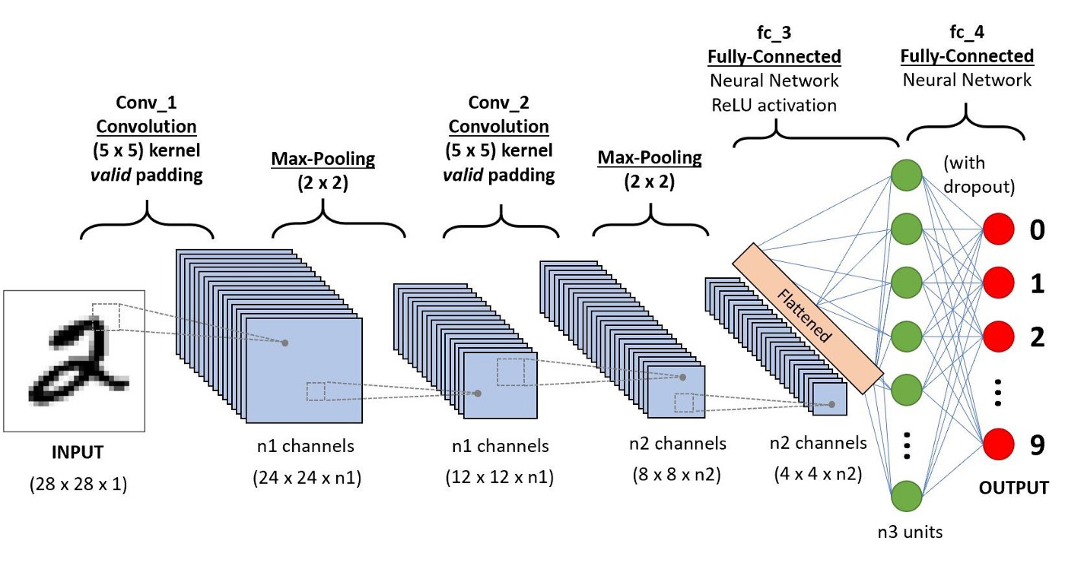

|  |
| --- |
| Key points:   * This paper, new features called Slope Detail (SD) features for handwritten digit recognition have been introduced. * These features are based on shape analysis of the digit image and extract slant or slope information. * They are effective in obtaining good recognition accuracies. * Import the libraries and load the dataset. First, we are going to import all the modules that we are going to need for training our model. * Handwritten digit recognition using MNIST dataset is a major project made with the help of Neural Network. * This could be a scanned handwritten document or a photo of a handwritten note, for instance. * OCR technology provides higher than 99% accuracy with typed characters in high-quality images. * Second, the image of the document is segmented into lines, words, and individual characters. * Defficulty is the issue is that there's a wide range of handwriting – good and bad. This makes it tricky for programmers to provide enough examples of how every character might look. |